Reduction of Waste generation in Solvent Paint Department using Six-Sigma approach
Ganesh Babu Pavalarajan
University of Nebraska -Lincoln
Abstract:
In business, waste often equates with inefficiency and lost profits. Waste reduction is therefore a core initiative of many companies' quality-improvement strategies. The cleaner and leaner operations can enhance a company's reputation, which in turn attracts more customers, builds brand loyalty and improves its investment profile, which increases its access to capital. In the broader context of the global marketplace, waste reduction can even have an impact on whether a company can operate its facilities or sell its products in certain countries. This paper discusses the benefits, a company would achieve by pursuing waste reduction initiatives. This paper is a case study of Six Sigma project on waste reduction for a leading paint manufacturing company in India. The objective of this study was to improve the sigma level of the paint packing process through the define-measure-analyze-improve-control (DMAIC) approach. At the early stages, pareto analysis and Quality Function Deployment matrix (QFD) were used to measure and analyze the current waste container generation in the shop floor. During later stages, design of experiment (DOE) was conducted to determine the optimal parameters of the critical-to-quality in the paint filling process. By using these optimal settings, higher sigma performance was achieved.
1. Introduction:
Manufacturing companies, government agencies, and service organizations are all facing greater demand from their customers for improved product and service quality. Many quality improvement programs and philosophies exist. Some organizations have used them with considerable success while others struggle to achieve their desired results.
A newly considered approach to quality is called Six Sigma. Six Sigma is a customer-driven method that structures proven quality techniques and concepts in a way which brings new relevance to quality management.
The goal of Six Sigma is to improve customer satisfaction through reduction and elimination of nonconformities. This goal is achieved, not through increased inspection activities which only add costs, but through continuous process improvement and reduction in process variation. Six Sigma organizations strive to generate fewer than 3.4 nonconformities per million opportunities in all processes that affect customer satisfaction.
Six Sigma Improvements are focused on the bottom line of the enterprise. The success achieved by Six Sigma is based on a disciplined, structures and proven process that has achieved of millions of dollars in savings. In general, this approach will drive the waste and cost out of the organization as quality improves, and customer satisfaction is increased through the continuous improvement in quality. Using the common measurement index of 'defects per unit', where a unit can be virtually anything including a line of code or an administrative form, companies have started to utilize the approach to reduce defects in non-manufacturing operations. The fundamental objective of this case study is to focuses on waste reduction and process improvement, through the application of special tools of DMAIC approach.
The opportunity for growth in Decorative paint sector and the need for sustenance of Market Leader position and need to cut down the unit cost of paint manufactured to increase the profitability of the firm has lead to the waste reduction initiative in the Solvent Based Paints department. The market potential for this paint is in increasing trend. With the existing resources company was not able to cater the market need. From the company’s point of view, the paint packing process is the most critical process that can affect the market supply. According to the current study, the sigma level of the process was not very satisfactory (DPMO - 78,683 Process Sigma - 2.91). Therefore, a study was conducted in the packing process with the objective of improving the sigma level.
2. Company background:
This case study was conducted in a paint manufacturing company located at an industrial park in South India. It is India’s largest paint company and ranks among the top ten decorative coating companies in the world. It is a 435 million dollar turnover company, with 6 manufacturing locations in India and 11 across the world. It offers a large range of decorative and industrial paints with a current market share of 45 % in the decorative paints in the Indian market segment. It is an ISO 9001 and ISO 14001 certified unit having annual production capacity of 120,000 tonnes of decorative coatings.
3. Five phases of the Six-Sigma approach:
The five core phases of the six-sigma approach are define, measure, analyze, improve, and control. Therefore, the six-sigma approach is also referred to as the DMAIC approach. The details of these phases are as follows [1]: In the define phase, the specific problem is identified, and the project goals and deliverables are defined. In the measure phase, a review of the types of measurement systems and their key features is included. The nature and properties of data collection must be thoroughly understood by companies. In the analyze phase, specific statistical methods and tools are used to isolate the key pieces of information that are important to explaining the number of defects [7]. In the improve phase, the key factors that cause the problem are discovered. In the control phase, the processes that create the product or service are controlled and monitored continuously in order to ensure that the problem will not occur again. The details of the DMAIC approach of this case study are as follows:
3.1 Define phase
3.1.1 Preface:
The increase in number of customer complaints and waste containers generated (Shown in Fig.1) from packing section over six months period was drastically high. The increase in waste generation had lead to high manpower overheads in housekeeping, segregation of wastes, and removal of paints from the containers. Also due to environmental restrictions paint had to be thoroughly cleaned from the containers before scrapping or re-using , moreover paint would not be disposed off, hence the waste paints were treated by effluent treatment plant (ETP). The ETP cannot cater the additional load driven by the wastes, this resulted in accumulation of wastes in scrap yard, making the place tidy. The recycling of usable paint needed additional validation before packing, leading to additional man power and equipment resources. With this background the project was taken-up.
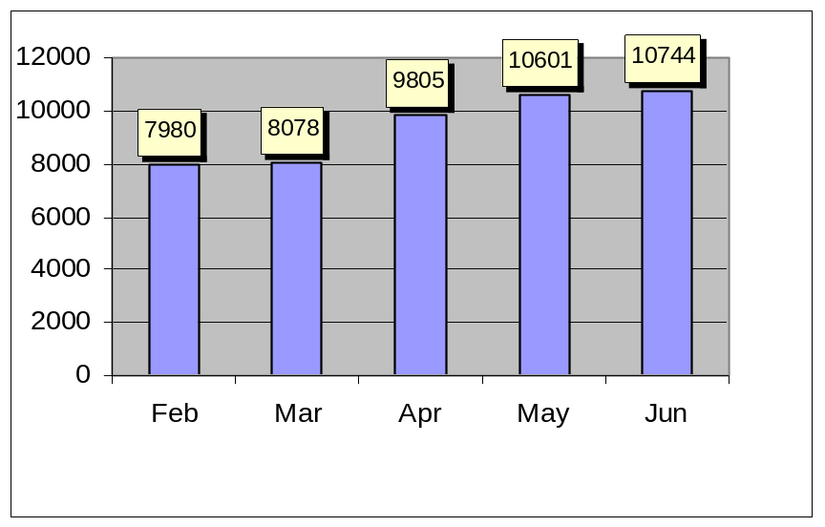

Fig.1 No. of Waste containers generated from Feb-02 to Jun-02

3.12 Macro Statement:
This project specifically focused on improvement of the sigma level of the paint manufacturing process. In this case the Critical to Quality (CTQ) is number of waste containers (tins) scrapped and the customer is Marketing and Environment Management Cell. The data showed on an average 9442 containers per month were scrapped over six months period with DPMO - 78,683 and Process Sigma - 2.91. On an average of 12.7 tins per tonnes of production was scrapped between these periods. The initial target fixed was to reduce the waste generation by 75% (since the management and team thought that 75% is achievable target). The target is 3.17 tins per tonnes of production. The response variable (number of waste container scrapped) data’s were obtained from environment management system once in a month. The duration of the project was six months.
3.2 Measure phase:
At the first team meeting, the project charter was reviewed with the team members to ensure clarity of purpose, goals and the parameters or scope of work involved. A process flow map also was completed. (Figure 2.a and 2.b) The development of the process flow map was a valuable exercise especially for team members who were getting their first view of the entire process and the role they played. The figure.2 shows the macro view of process flow and the waste generated area. Figure.2 shows the process flow for the waste containers.
Receipt of
Packing. material
Paint
Packing Line
Container Lidding machine
Operation
Pigments
Grinding

Additives Mixing

Paint Processing
machine

Batch Approval by
Q.C
Stacking on
the Pallet
Finished Goods
Storage Room
Paint Packing
Paint Processing
Paint Filling Machine
Operation
Waste
Fig.2a Process Flow Diagram for Paint Manufacturing

Generation of defects
during packing

Processing
Section
Red
bins
Transfer of waste container to storage place
Storage Area
Cleaning of containers using
Mineral Turpentine Oil
Scrap Yard
Packing
Fig. 2b Process Flow for Defective Container

All processes can be viewed as a series of inputs or factors (x's) contributing to the output (Y). In other words, every process can be expressed in terms of the mathematical equation Y=f(x), where Y is a function of x [3]. In this case, example Y was number of waste containers generated, and the x's were the various factors contributing to it. The next step was to identify all the factors (x's) potentially impacting the waste container generation (Y) by completing QFD [6] as shown in Fig. 3.
KPOVS | Defective Containers | Re-cycling of paint | Load on Effluent Treatment plant |  | Man power overhead | Validation process | CPR X Effect | Rank
CPR | 10 | 5 | 3 |  | 4 | 8 | CPR X Effect | Rank
KPIVS
Vendors | 10 |  |  |  |  | 8 | 164 | III
In-process generation | 5 | 7 |  | 8 | 5 |  | 139 | V
Machines | 10 | 9 |  | 7 | 8 | 5 | 238 | I
Operators | 9 |  |  |  | 7 | 6 | 196 | II
Packing returns | 7 | 8 |  |  | 8 | 2 | 158 | IV
Fig.3 Quality Functional Deployment Matrix
3.2.1 Constraints:
The following were the constraints team faced in this phase
- Data of Supplier defects was incomplete
- Data of Machines used for packing was not available
- Data of Operators Deployed was not available
- Data of In-process generation was not available
Formats for capturing data were designed and introduced in the different process to collect accurate data.

3.3 Analyze:
The fishbone diagram was a useful technique in helping team members articulate all the possible contributors to waste generation versus the few that typically come to mind. Completion of a fishbone diagram was also essential in identifying all the potential contributors to process variations - a fundamental principle of the Six Sigma approach. For example, in this case (Fig.4), some of the x's included paint filling machine, supplier defects, In-process generation, operator etc.
Fig.4 Cause and Effect Diagram
Methods
In-process Sampling
Packing
Materials
Supplier Defects
Customer Returns
Packing Returns
Lack of knowledge
In-proper operation
In-proper Handling of finished product
Men
Paint spill on lid
Over flows
Lid fitment problem
Machines
Waste container generation
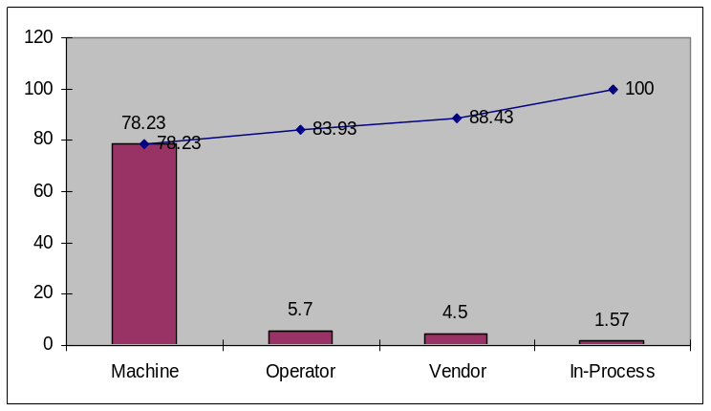
The first step of the Pareto Analysis is to gather data on the frequency of the causes [5]. The data (causes) captured was based on the outcome of the cause and effect analysis

Fig.5 Pareto analysis
The pareto analysis revealed that 78.23% of the wastes are generated from the machine, shown in Fig.5.
The data also showed group-1 Paint Filling Machines comprising of 7 semi-automatic machines generate high wastes rather than group-2 of 5 automatic machines. The bar chart of average number of defective containers per month and its percentage for two groups are shown in Fig.6
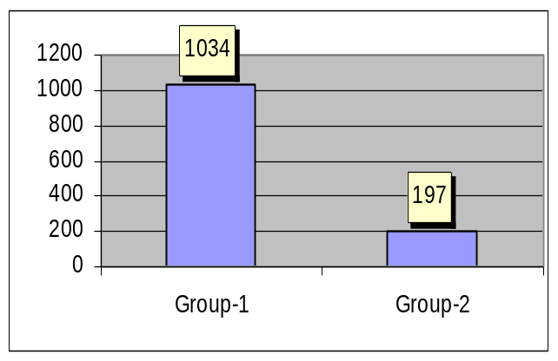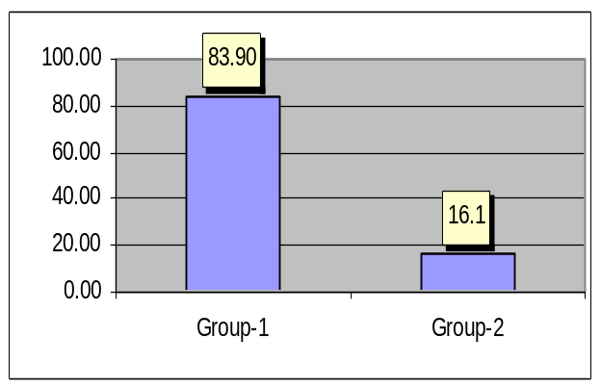

Fig.6a Avg no. of defective containers / month Fig.6b Percentage defective containers

The group-1 machines were semi-automatic machines, due to the constraints in the budget all the group-1 machines could not be converted to automatic machines. The 16.1% waste generated in group-2 was mainly due to initial setting errors and operator’s mistakes. The feasible way of reducing the waste generated in the group-1 machines was to modify the machine parameters which lead to the wastes. The parameters found to be affecting the performance of the machine is paint viscosity, shut-off valve and paint feed rate [4]. A 3³ factorial design (DOE) without blocking was carried for three replications [2], the factors and levels are shown in Fig.7.
Valve angle | Viscosity | Feed Rate
30 | 30 | 50
37.5 | 35 | 55
45 | 40 | 60
Fig.7 Factors and levels of DOE

Source DF Squares Mean Square F Value Pr > F
Model 18 61354.51852 3408.58436 320.98 <.0001
Error 62 658.39506 10.61928
Corrected Total 80 62012.91358

R-Square Coeff Var Root MSE Container Defects Mean
0.989383 5.701006 3.258723 57.16049

Source DF Type I SS Mean Square F Value Pr > F
Valve angle 2 50985.3580 25492.67901 2400.60 <.0001
Viscosity 2 52.0240 26.01235 2.45 0.0946
Feed Rate 2 8789.06173 4394.53086 413.83 <.0001
Valve *Visco 4 41.75309 10.438 0.98 0.4235
Visco*Feed 4 212.04938 53.012 4.99 0.0815
Valve *Feed 4 1274.27160 318.567 30.00 <.0001
Fig.8 ANOVA for defects generated
The ANOVA table (Fog.8) shows the P-value, which tests the statistical significance of each factor. From the Table, it is evident that P-value of the main factors: Valve angle, Feed rate and its interaction were less than 0.05. Hence these factors had statistically significant effect on the defects generated at 95% confidence interval.
The spilling phenomenon happened in the filling machine whenever the machine shut-off valve orientation changes because of numerous operations. This valve was operated by pneumatic reciprocating cylinder. From the analysis we could infer that whenever machine operated at high feed rate (60 tins/minute) at 30-45 degree shut-off valve angle the paint spilled and dripped over the container and lids. It resulted in defective containers, which eventually rejected during the quality check.
3.4 Improve
Armed with this information, improvement efforts were concentrated on group-1 Filling machine shut-off valve angle and feed rate. A standard operating procedure related to operation of machine was developed and implemented, with accountability clearly identified. It was this communication to stakeholders that really began to drive change within the organization. A previously unknown factor was found to be significant, and this translated into a new process and improved performance. The improvement shown by both the filling machine group for six months is shown below Fig.9a & 9b. The DPMO and Process Sigma were found to be 17,633 and 3.61 respectively. The cost benefits out of this project was $115,400.

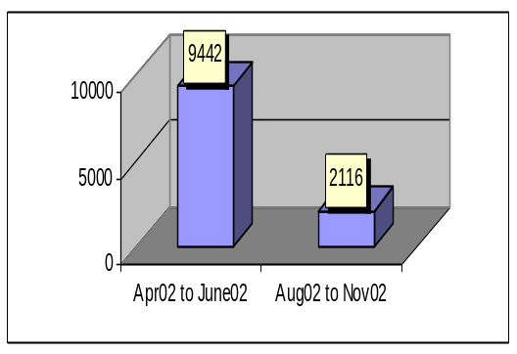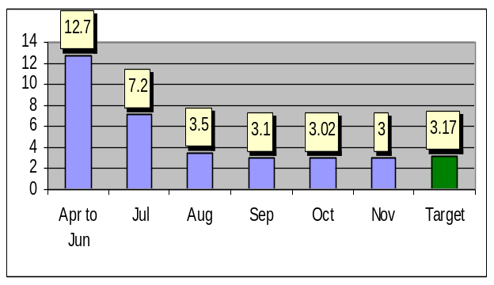

Fig.9a No. of Waste generated /month Fig.9b No. of Tins Scrapped /tonnes
3.5 Control
The Control phase is perhaps the most important part of the DMAIC process. It also is the step most frequently overlooked. In this case, data collected during the Define and Measure phases indicated that the number of tins scrapped per tonnes of paint production is 12.17. After improvements were put into place, this was found to be 3 tins per tonnes of paint production. In order to sustain the improvement the following control plans were put in place.
- Preventive maintenance for shut-off valve alignment once a week
- Filling Machine’s Feed rate is set to 55 tins/minute with help of Programmable Logic Circuits (PLC) and included in the SOP.
- Predictive Maintenance Schedule to check the shut-off valve wear rate
- Deployment of skilled operator
- Sectional Performance Graphs display to Educate Supervisors & operator on waste generated.
Alternative Control plan:
Following is the alternative control plan, based on the budget it could be implemented.
- Suggested usage of Hardened steel to reduce the wear rate of valve
- Suggested Lapping of valves during preventive maintenance
- Suggested to upgrade the filling cylinder to servo mechanism
- Quarterly Audits on filling machine
4. Conclusion:
This case study illustrates the impact of Six Sigma in a paint manufacturing environment. This methodology had helped to evaluate the performance, improve quality initiatives, and renew employee spirit by creating a right kind of manufacturing environment.

References:
- Schroeder R (2000) Six Sigma: the breakthrough management strategy revolutionizing the world’s top corporations. Doubleday, New York

- Design and Analysis of Experiments, Douglas C. Montgomery, second edition, John Wiley & Sons

- www.isixsigma.com

- Paint and Surface Coatings: Theory and Practice, 2nd Edition, R. Lambourne and T.A. Strivens

- www.qualityadvisor.com/sqc/paretodiagram.htm

- www.qfdi.org

- A DMAIC approach to printed circuit board quality improvement, International Journal of Advanced Manufacturing Technology (2004) 23: 523–531

